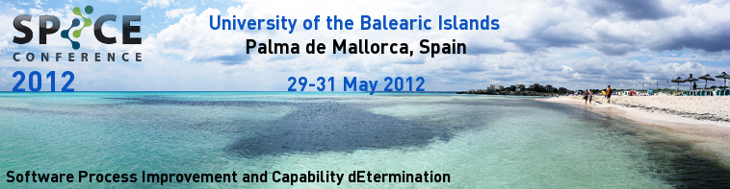
SPICE 2012 Conference Registration
Attendee Personal Information
Mr.: Mrs.: | Title:
First Name: | Last Name:
Paper author: Yes: No: | Paper title:
Organization/Affiliation:
Phone: | Fax:
E-mail:
Name badge information (as you want your name badge to read):

Special dietary/physical requirements (if any):

Billing Information
Organization/Affiliation: | Tax Code:
Address Line 1:
Address Line 2:
Postal / ZIP code: | City:
State (if applicable): | Country:
Accompanying Person
Mr.: Mrs.: |  | Title:
First Name: |  |  | Last Name:
Special dietary/physical requirements (if any):

SPICE 2012 Conference Fees

The registration fee for participants includes:
- Attendance to all conference sessions and keynotes.
- Conference proceedings.
- Welcome cocktail, lunches; morning and afternoon breaks.
- Conference dinner (not included in student registration fee).

CONFERENCE  Wednesday and Thursday, May 30 - 31, 2012 |  | Before April 18th | After April 18th
Standard Registration Fee |  | 475 euro | 575 euro
Student (full time) Registration Fee * |  | 300 euro | 400 euro
* Proof of full time student status will be asked for at the conference. Student fee includes participation in the conference, proceedings, tea/coffee breaks, lunches and welcome reception. Conference dinner is not included. Students are welcome to attend conference dinner. The cost of the tickets for the conference dinner is €70.
TUTORIALS
Tuesday, May 29, 2012
Full day tutorial |  | 400 euro
Half day tutorial |  | 200 euro
Please select which tutorial(s) you wish to attend
9:30-13:00 | innoSPICE (Michael Boronowsky, Tanja Woronowicz, Antanas Mitasiunas)
9:30-13:00 | Facilitation For SPI (Hajime Shiraishi)
9:30-13:00 | Increase Project Success With Scope Management And Leadership (Carol Dekkers)
14:30-18:00 | Process Improvement With Enterprise SPICE (Linda Ibrahim, Ernest Wallmueller)
14:30-18:00 | The Role And Application Of ISO/IEC 15504 (Terry Rout)
14:30-18:00 | Safety Issues In Process Assessment (Risto Nevalainen, Timo Varkoi)
ADDITIONAL ITEMS
Student ticket for conference dinner |  | 70 euro
Additional guest ticket for conference dinner |  | 70 euro
Additional conference proceedings  Note: Post-conference price from Springer will be €58 |  | 50 euro
Total amount payable: |  | euro

